# Prototype Implementation Decisions

Implemented Design: (27/06/2023)

| **Main Panel** | **Compose Task** | **Detailed Page (ToDo)** | **Detailed Page (Done)** | **Confirm Action** |
| --- | --- | --- | --- | --- |
|  |  |  |  |  |

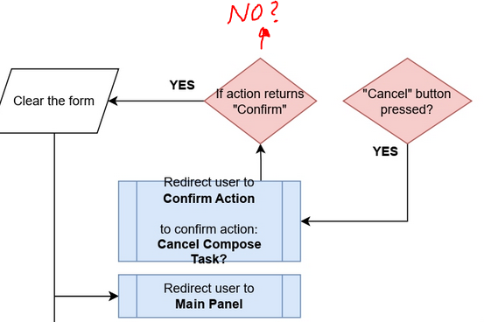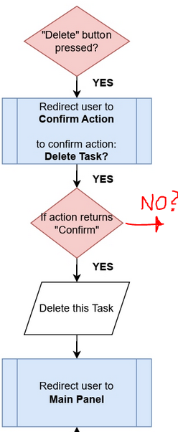We have implemented an appropriate design to meet the specified software-development-process documentation requirements. However, we require an iteration of some flow charts related to redirecting the user to the "Confirm Action" page because there is a lack of an exit point after confirming the action's cancellation and questionable redirection to the "Main" page upon cancellation at "Confirm Action" wire-frame.

It is expected that the user is redirected back to their progress upon cancelling critical action such as post form from a standard UI procedure. In our case, user composing a task can cancel their progress, which prompts them to confirm their intent on the "Confirm Action" page. Hence, upon cancellation of critical action, the user should be redirected back to continue composing their task, which is not the case according to our wire-frames documentation.

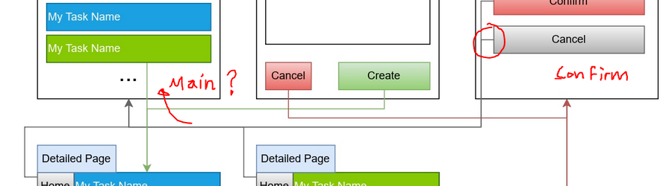

Additionally, the prompting to “Confirm Action” page deletes the user's progress. There are a couple of solutions that can help us solve this issue, mainly local storage and cookies. In our case, cookies can be beneficial as they contain an expiry date. However, saving data before prompting to the "Confirm Action" page is not specified.

There are more issues:  
  
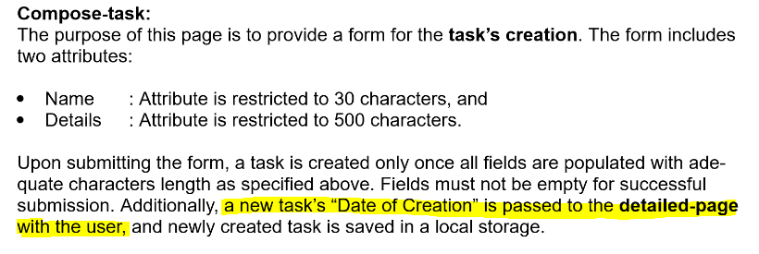

This is not an ideal approach for tackling the user's and newly created task's redirection. It's best to define, validate and create the new task before redirecting the user to the “Detailed Task” page. I also assume that redirecting intent is to display a newly created task. The confusion derives from both wire-frames and flow-charts diagrams as both redirections are inconclusive.

Wireframes:

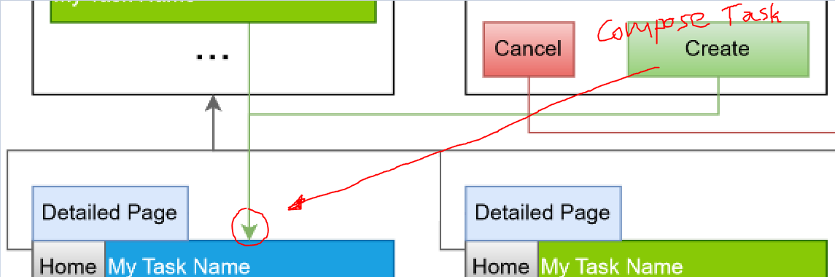

Flowchart-ComposeTask:

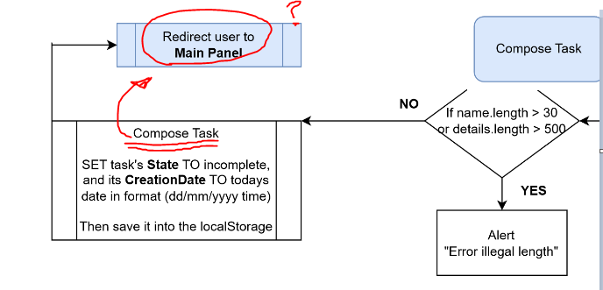

In short, iteration is required to fix the application's navigation and data flow in terms of temporary savings as we implement critical functionality for the final product.